1. 
2. This is the final topic in the series of designing a good RESTful API.
3. 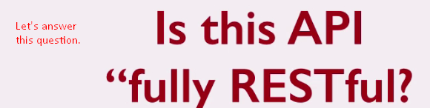  
   How to know whether the API you designed is fully RESTful or not?  
   There is a **model by Leonard Richardson** called **Richardson Maturity Model**.  
   This model breaks all the concepts we discussed so far into 3 different levels.  
   Every RESTful API belongs to one of these 3 levels. Model also define level 0 which means the API is not RESTful at all.   
     
   We know that in SOAP WS, there is only one URI (Endpoint) for all kinds of operations CRUD ( or any).  
   How does server know what to do?  
   Along with the request, request body contains the detail event about the operation that is to be done.  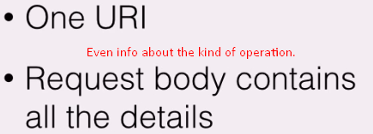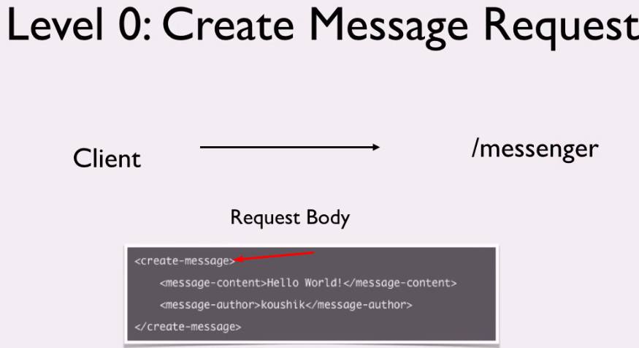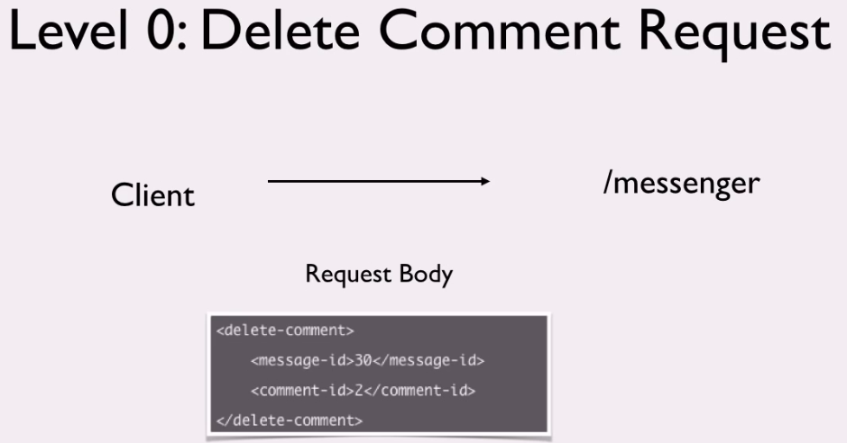  
   Even the same HTTP method can be used for the all kinds of operations as the kind of operation is part of the request message body.  
   This is level 0 in the Richardson Maturity Model. This is **also called🡺****  
   This** refers to the common use of **P**lain C**o**mmon **X**ML to define everything as XML. There is no leverage for HTTP Methods.   
   This design, you would not like to use when designing the RESTful API.
4. You can redefine this model and introduce the concept of Resource URI and you reach level 1 in the Richardson Maturity Model. This is the starting level for RESTful API. For each resource, there is unique URI called Resource URI not using one URI for all resources. 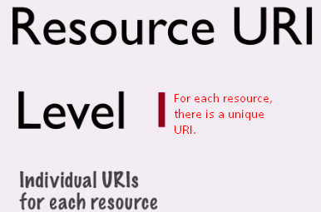
5. If you take one more step by introducing HTTP methods for different operations for each resource, you reach **Level 1 in Richardson Maturity level**. 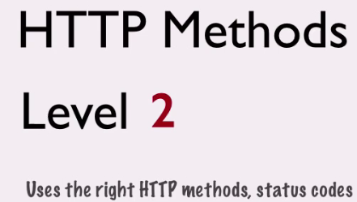  
   Now, the URIs specifies the resources on which operations to be done and the HTTP methods specify what operation to be done on the resource.
6. **Level 3**: when you implement HEATOS that the response has links that control the application state. Now clients don’t need to be aware of the API URIs. 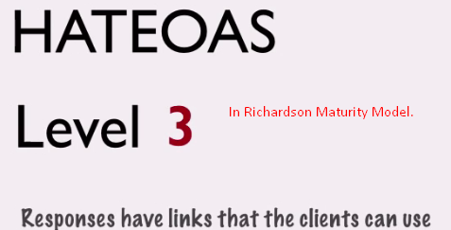
7. **NOTE:** There is no hard and fast rule to achieve these levels as per Richardson Maturity Model but it’s good guideline.